***Follow the instructions given in red. DO NOT TYPE IN THESE RED BOXES!***

***This is the title page of the Physics Lab Report. Please change the:***

***title,***

***your name and student number,***

***teacher's name,***

***due date***

***number of pages.***

***Edit the following title page entries now:***

Electric Power & Torque

# Objective:

The aim of this experiment is to Calculate Electric work & Torque at different pressures.

# Introduction

A steam power plant is a sophisticated technology that offers a highly efficient and environmental-friendly power generation facility. The main component is the steam power plant is a boiler that generates high-pressure steam. The steam is then sent to the turbine that converts heat energy into mechanical work by rotating a generator motor (Dincer, 2001, pp. 727). The rotating action of the generator shaft causes electricity to generate.

There are five stages in a steam generation cycle: coal ash handling, steam generation system, turbine and alternator, and feed water cooling. Therefore, the primary function of the steam power plant is to convert raw energy in mechanical or electric work through steam generation.

# Safety

Remember that you will be dealing with high pressures and temperature safety depends both upon following the specific instructions of the manufacturer and upon using good common sense as well.

# Apparatus

* TH 120 Mini Steam Power Plant
* Load Cell

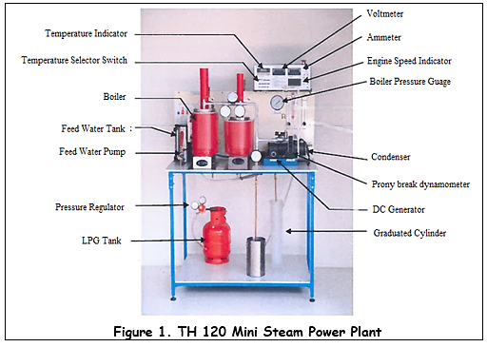

# Theory

* The Rankine cycle is the most common of all power generation cycles and is diagrammatically depicted via Figures 1 and 2.
* The high-quality vapor is expanded isentropically through a steam engine cylinder to produce shaft work. The steam then exits the Steam engine.

|  |
| --- |
| Figure 2. Schematic of the thermodynamics process of the steam power-plant |

# Procedure

1. Start the Boiler
2. Close the engine vent valves **V1, V2, V3, V4 and V5.**
3. Adjust the fuel flow at the fuel rotameter to around **2.5 l/min** for boiler.
4. Ignite the burner by turning the igniter.
5. Open the valve and adjust the water flow rate of condenser at around **2.5 l/min**.
6. After 2-3 min open valve **(V2)** then open **slightly valve (V5)** at **intermittent time** for bypassing residue moisture and air inside to atmosphere.
7. Tum **ON** the power system of the test set so that temperatures can be observed
8. When the steam pressure (P1) is over required pressure  **open and adjust the bypass valve (V5)**.
9. Fuel flow rate **(Fl) to about 2.0 L/min**
10. Switch on load cell and record RPM, Volt & Current at different pressures
11. The boiler is designed to operate up to **5 kg/cm2** and the boiler relief valve at **5.5 kg/cm2**.

# Observations

**Table.1. Raw data collected during performance**

|  |  |  |  |  |  |
| --- | --- | --- | --- | --- | --- |
| Gauge Pressure  P1 (Kg/cm2) | Speed of Engine  N (RPM) | Volt  (V) | Current  (A) | Electric Work (Watt) | Torque  (N.m) |
| 2.0 | 840 | 5.5 | 0.239 | 1.314 | 0.015 |
| 2.6 | 1030 | 6.59 | 0.275 | 1.812 | 0.021 |
| 3.2 | 1187 | 7.45 | 0.31 | 2.302 | 0.026 |
| 3.8 | 1311 | 8.19 | 0.345 | 2.825 | 0.032 |
| 4.4 | 1518 | 8.99 | 0.372 | 3.344 | 0.038 |

# Formula Used

|  |  |
| --- | --- |
| Power and Torque: Identify equations to find Torque T in N.m | ${\dot{W}}_{e}$ = $\frac{2πNT}{60}$ Watts; ${\dot{W}}_{e}=V*I$ Watts |
| Units Conversion: | 1 Kg/cm2= 98 kPa |

# Results and Calculations

|  |  |  |  |  |  |
| --- | --- | --- | --- | --- | --- |
| Gauge Pressure  P1 (Kg/cm2) | Speed of Engine  N (RPM) | Volt  (V) | Current  (A) | Electric Work (Watt) | Torque  (N.m) |
| 2.0 | 840 | 5.5 | 0.239 | 1.314 | 0.015 |
| 2.6 | 1030 | 6.59 | 0.275 | 1.812 | 0.021 |
| 3.2 | 1187 | 7.45 | 0.31 | 2.302 | 0.026 |
| 3.8 | 1311 | 8.19 | 0.345 | 2.825 | 0.032 |
| 4.4 | 1518 | 8.99 | 0.372 | 3.344 | 0.038 |

**For Gauge Pressure 2.0 Kg/cm2**

**For Gauge Pressure 2.6 Kg/cm2**

**For Gauge Pressure 3.2 Kg/cm2**

**For Gauge Pressure 3.8 Kg/cm2**

**For Gauge Pressure 4.4 Kg/cm2**

# Plots / Graphs

* Plot ${\dot{W}}_{e}$ vs **Pressure**
* Plot **Torque vs Pressure**

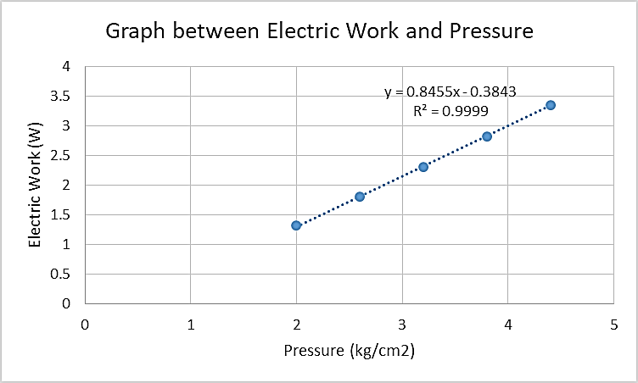

**Figure 3. Graphical representation of electric work and pressure**

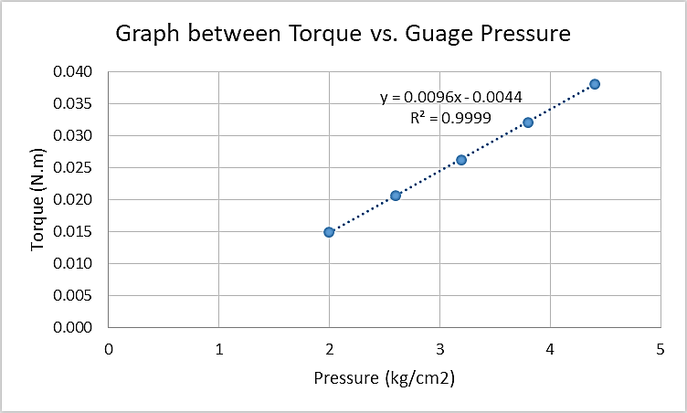

**Figure 4. Graphical representation of electric work and torque**

# Discussion:

The experiment involves the study of the steam power plant and effect on the plant’s performance by varying pressures. The investigation utilized TH 120 Mini Steam Power Plant in which high-pressure steam entered into the turbine and expands after transferring energy. Besides, turbine steam inlet pressure affected the performance, as low pressure produces low power output. According to Rao (2012), a 10% increase in the pressure of superheated steam will reduce steam utilization by 1% and increases 1.5% of total efficiency (pp. 2-3). The study of analyzing the system variable in terms of physical quantity helped in process optimization and parametric evaluation of the steam power plant.

The results from the experiment were tabulated in Table 1. The pressure was gradually increased from 2.0, 2.6, 3.2, 3.8, to 4.4 kg/cm2. The corresponding voltage and current were calculated for each pressure. The values were utilized to calculate electric power and torque using formulas. From the calculated results, the lowest electrical work (1.314 W) and torque (0.015 N.m) were obtained for 2.0 kg/m2, and the highest values were 3.34 W and 0.038 N.m for 4.4 kg/m2. The results in Figures 3 and 4 were found to be directly related to each other, which is in accordance with the theoretical assertions. The fact was found valid as high-pressure steam improved thermal efficiency and workability. The dynamics of work done of the turbine by steam was found dependent on the steam pressure, which affected the torque of the prime mover.

Factors such as controlling flow through the nozzle may help in achieving the precision of the experiment. Therefore, it is recommended to consider parameters such as blade geometry, flow characteristics, and recycling effect in order to understand the process more clearly. There were be some sources of error due to human error, inaccurate instrument readings, pressure variations, and corrosion between the moving components. Using precautionary measures can improve the accuracy of the experiment by minimizing the error.

# Conclusion:

The experiment was successful in demonstrating the working of the steam power generation plant. The relationship of both electrical work and torque was found directly proportional to the system pressure. The increasing pressure affected the power generation and overall efficiency of the pilot plant. The research findings cleared the concepts of mechanical thermodynamics and heat transfer.

*The attachments include all original data or observations of the experiment.*

*Add your attachments below:*

# References

Rao, A. D. (Ed.). (2012). Combined cycle systems for near-zero emission power generation. *Elsevier*, pp. 2-3.

Dincer, I., & Al‐Muslim, H. (2001). Thermodynamic analysis of reheat cycle steam power plants. *International Journal of Energy Research*, *25*(8), 727.

**Breakdown of Marks for the Report Writing**

|  |  |  |  |
| --- | --- | --- | --- |
| 1. | Participation/Work independently/Oralquestions/pre-lab quiz | 30 |  |
| 2. | Troubleshooting and problem solving/ post lab test | 10 |  |
| 3. | Introduction/ Objective/ Procedure | 5 |  |
| 4. | Calculations /Codes/ Theory. | 5 |  |
| 5. | Data collection/ Findings / observations | 5 |  |
| 6. | Diagrams / Charts / Figures and Plots with Captions | 10 |  |
| 7. | Analysis & Discussion | 15 |  |
| 8. | Conclusions/ Summary /self-reflection | 15 |  |
| 9. | Quality of work performed including quality of lab report, neatness etc. | 5 |  |
|  | **Total** | **100** |  |